**Basics of Management**

**MGT 201**

Project – **MakeMyTrip Limited**

Semester IV

Program – B.Tech Batch 2015-19

**Group no – 45**

**Section – S4**

Members:

Lisa Krishania: U101115FCS238

Kundan Dewangan: U101115FCS244

Lakshay Dhupar: U101115FCS198

Lavkush Singh: U101115FCS113

M Praveen: U101115FCS126

Mandala Sai Kushal: U101115FCS114

**Index**

* Corporate Profile
* About the Company
* Corporate Structure and Business Model
* Company’s CEO Profile
* Organisation Structure and Culture
* How does the company make money and function
* Verticals, Services and Products
* Recognition and Awards
* Industry and Competitive Scenario
* Competitors and Challenges Ahead

**Report – ‘MakeMyTrip Limited’**

**Corporate profile**:

MakeMyTrip Limited is the parent company of MakeMyTrip (India) Private Limited, the leading online travel company in India, MakeMyTrip Inc. (USA), MakeMyTrip FZ-LLC (UAE), Luxury Tours & Travel Private Limited (Singapore), Luxury Tours (Malaysia) Sdn. Bhd. (Malaysia), Hotel Travel Group (Thailand), ITC Group (Thailand) and the ETB Group (The Netherlands).

Visit [Source](http://investors.makemytrip.com/phoenix.zhtml?c=238356&p=irol-irhome): http://investors.makemytrip.com/phoenix.zhtml?c=238356&p=irol-irhome (compiled on 21.01.2017)

**About the company**:

MakeMyTrip Ltd was founded in the year 2000 by Deep Kalra, former Chairman and Group CEO of the company. It initially was launched in US market to offer flight services to Indian Communities. For US travel needs. Rajesh Magow was appointed as CEO – Indian Region in August 2013.

**Corporate Structure and Business Model:**

Headquartered in Gurgaon, Haryana, this company operates primarily through website, <https://www.makemytrip.com>, provides with online travel services from flights to buses, non-air businesses like hotel bookings, holiday packages etc. Recognised as one of the best ‘travel portals’ online, it also operates through 65 retail stores across 50 cities in India. Current revenues statistics are US$255.37 Million (2013-14) with 1,712 employees as on March 2014.

View [Source](https://en.wikipedia.org/wiki/MakeMyTrip): <https://en.wikipedia.org/wiki/MakeMyTrip> (as on 25.02.2017)

1. **Table 1:** Place of formation and ownership interest.

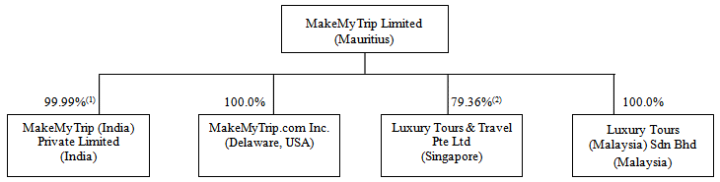

Visit [Source](https://www.sec.gov/Archives/edgar/data/1495153/000095012311082290/c22065c2206501.gif): <https://www.sec.gov/Archives/edgar/data/1495153/000095012311082290/c22065c2206501.gif>

(Compiled on 21.01.2017)

1. Formation and Distribution

* Created network of offices in New Delhi, Mumbai and New York
* Appointed franchise partners in US, UK India and Australia
* Operates as separate entities, MakeMyTrip Ltd. (India) and MakeMyTrip Inc. (USA)
* Three Modes of Communication to sales/customer service team, vis emails, web chats and correspondence through toll free numbers

**Company’s CEO profile:**

Deep steered MakeMyTrip as the CEO of the company since its inception in 2000, to a successful listing on NASDAQ in August 2010. He took on the role of Group CEO in August 2013 to focus on Strategy, M&A and the international businesses. He is still leading the Group’s strategic developments along with overall execution excellence.

Deep has also been recognized by Ernst & Young as Entrepreneur of the Year - Business Transformation (2011), as the most powerful Digital influencer in India (2012) by KPMG and 'Internet Man of the Year' (2010) by IAMAI. TTG Asia awarded him The Best Travel Entrepreneur of 2012 at the TTG Travel Awards. Deep was also felicitated as a ‘Distinguished Alumni’ of IIM-A during the celebrations of the Institute’s Golden Jubilee in December 2011.

Visit [Source](https://www.makemytrip.com/about-us/management.php): <https://www.makemytrip.com/about-us/management.php> (as on 23.03.2017)

**Organisation Structure and Culture:**

**Organisational structure:**

‘Organisational Structure’ is how job tasks are formally distributed, grouped and coordinated. Work Specialization

Organisational structure differs accordingly that influence the design like Strategy, Organization Size, Technology and Environment.

‘Wide span’ organisational structure is followed by the company, MakeMyTrip Limited.

1. Top Managers with their designations:

* Deep Kalra : Chairman & Group CEO
* Rajesh Magow : Co-Founder & CEO – India
* Mohit Gupta : Chief Operating Officer (of Online related issues)
* Mohit Kabra : Chief Financial Officer
* Ranjeet Oak: Chief Business Officer (Holidays Dept.)
* Yuvaraj Srivastava: Chief Human Resource Officer
* Saujanya Shrivastava : Chief Marketing Officer
* Anshuman Bapna : Chief Product Officer
* Sanjay Mohan  : Chief Technology Officer
* Ritwik Khare : Senior Vice President and Head, Business Development (of Hotels)
* Deepak Tuli : Senior Vice President - Growth Business

Visit [Source: https://www.makemytrip.com/about-us/management_list_view.php](Source:%20https://www.makemytrip.com/about-us/management_list_view.php%20) (Compiled on 25.02.2017)

**Organisation culture:**

Organisation Culture, refers to the set of values, beliefs and norms, together with symbols like dramatized events and personalities which represents the unique character of an organization/

MakeMyTrip Ltd. ensures the interest of employees at the workplace. Being transparent, provides balanced treatment in terms of rewards and other measurable parameters. Enforce Impartiality in promotions and hiring process. Profit sharing and bonus plans, where employee can calculate their increment amounts in prior to the duration.

**How does the company make Money and function?**

Travel aggregators like Make My Trip manage to get bargain deals with hotels/flights because of the reach they have established with travellers/users. This means that they can offer lower rates to customers while still taking a commission for all booking made through their website. Basically, there are many ways to make money from internet platform. Some of them related to make my trip site are as follows:

* There are considerable investments from various entities for promotion.
* They can charge hotels which want to partner with make my trip through tie-ups.
* Furthermore, money can be earned through mode of payments such as PayPal, American express, visa and other.
* By offering a best price guarantee, hoteliers know that customers will be more inclined to visit MMT than to visit the hotel’s site directly They use this mode to make money in CPC (cost per click) advertising as we can see pop ups on their page regularly.

**Table 2**: MakeMyTrip Limited Operating Expenses.

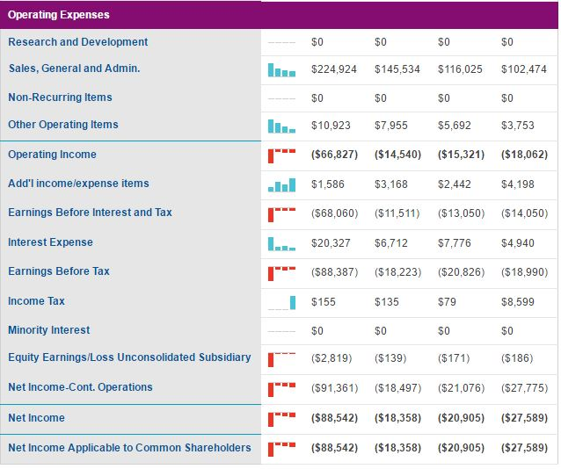

Visit [Source](http://www.nasdaq.com/symbol/mmyt/financials?query=income-statement): <http://www.nasdaq.com/symbol/mmyt/financials?query=income-statement> (Compiled on 09.04.2017)

For Example Make My Trip (MMT) wants to offer seven-night, all-inclusive vacations for two in Malaysia, it contacts a hotel in Malaysia and asks to buy a block of 100 rooms at $50 a piece instead of their Best Available Rate (BAR) of $90. MMT then contacts airlines and makes 200 seat reservations to Malaysia for $600 (with little discount). The package is offered to guests at a cost of $1,700 for two people. People booking on MMT are happy; they have saved $130 off the list price just by booking with MMT! MMT shareholders will happy because they have only paid $1,550 for a package they have sold to 100 couples for $1,700. Everyone wins.

**Verticals, Services and Products:**

A journey from a sun-rising idea to entitle travelling - MakeMyTrip went on to pioneer the entire online travel industry in India. Here is the brief described journey of the largest online travelling portals:

MakeMyTrip.com, began its journey in the US-India travel market, offered a range of best-value products and services along with latest incorporated technology and customer service support.

Soon after securing a good recognition in the market, MakeMyTrip followed its success by launching ‘India operations’ in 2005 in the United States.

With a strategy to grab the opportunities in the domestic travel market, brought on by the entry of new airlines, MakeMyTrip offered its travellers with the convenience of online travel bookings at lowest prices possible. Company now was the choice of many customers, which helped them with travelling services in just a few clicks.

**Table 3:** Revenue of MakeMyTrip- Constantly Rising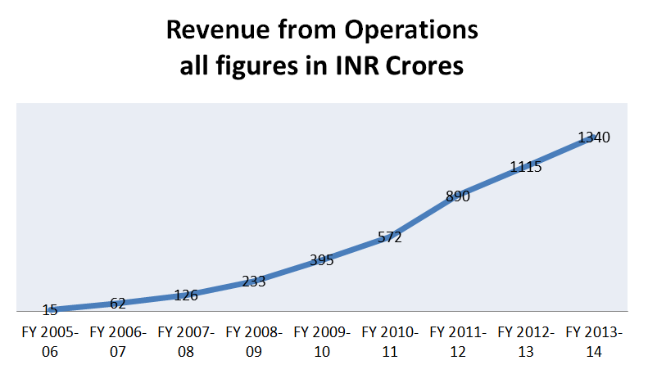

Visit [Source](https://www.tofler.in/blog/wp-content/uploads/2015/10/MakeMyTrip-Revenue1.png): <https://www.tofler.in/blog/wp-content/uploads/2015/10/MakeMyTrip-Revenue1.png> (Compiled on 09.04.2017)

MakeMyTrip’s rise has been powered by the vision and the spirit of every of its employees. With the constant growing instinct, MakMyTrip felt the need to expand its services into different sectors and implemented the idea of successful expansion of the services across different product lines. MakeMyTrip led in the race by evolving its technology with time to meet the changing demands of the fast-growing travel market globally.

Along with expanding and self-establishment, the company also focussed on the growth of other of its offline businesses e.g. franchises and affiliates in parallel, which further augmented its strong present in retail.

One-stop-travel-shop, the company now is more than a travelling asset, providing a wide range of products and services in India. Now, as per the statistics, being a dominating market-leader, MakeMyTrip hold 47% market-share pie (As per PhocusWright, 2013), a fact by the trust placed in it by numerous customers.

MakeMyTrip has remained reliable, efficient and at the forefront of technology. Its commitment towards customer satisfaction allows it to better understand the needs and provide for its customers’ diverse features consistently. A feature of 24x7 customer support, offices in 20 cities across India including 2 international offices in New York and San Francisco (along with several franchise locations), MakeMyTrip is there for you, whenever and wherever, any time, any place!Visit [Source](https://www.makemytrip.com/about-us/company_profile.php): <https://www.makemytrip.com/about-us/company_profile.php> (as on 21.03.2017)

**Table 4:** Annual Income Statements

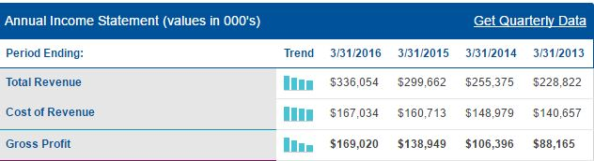

Visit [Source](http://www.nasdaq.com/symbol/mmyt/financials?query=income-statement): <http://www.nasdaq.com/symbol/mmyt/financials?query=income-statement> (Compiled on 09.04.2017)

The company has evolved with changing environment, adapting to the needs of the customers and incorporation of features of mobile solutions to ease up the experience. Services includes:

* Flights - flight tickets in both, domestic and international regions.
* Rail And Bus tickets
* Cab Services
* Non- aired businesses like booking Hotels, planning Holidays(in both, domestic and international accommodations)
* Mobile solutions – in the form of mobile apps for all platforms, e.g. windows phone, android etc.
* Route planner – basic route plan information online from source to destination

The company offers competitively offer priced travel products with real time booking capability. Features include:

* Real time booking capability
* Entire travel facility and services online
* Allows hassle free customer services, online chats, toll free number assistance
* Offers travel insurances, access to business lounges, and shopping discounts to attract customers
* Also offers information about visas, passports, insurances, travel and finances etc.

Customer Interface:

* Makemytrip.com
* Franchisee Stores

Services that support their product lines:

* Call Centres
* Travel Executives

**Table 5**: Market – Domestic and International statistics:

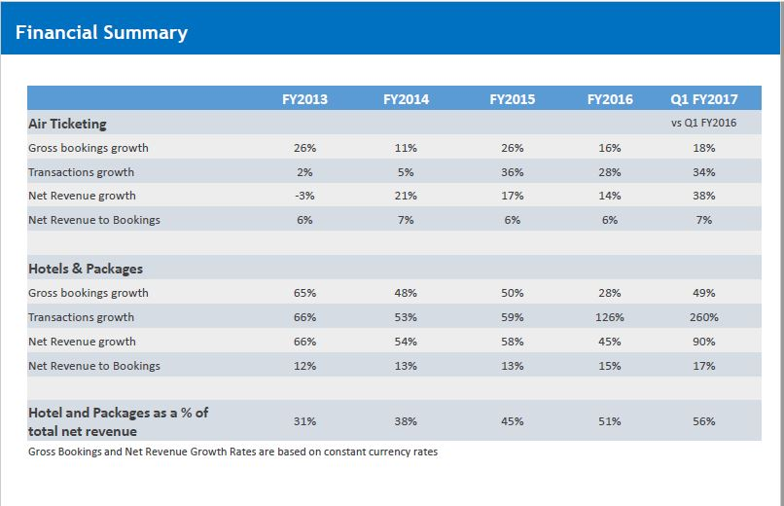

Visit [Source](http://investors.makemytrip.com/phoenix.zhtml?c=238356&p=irol-presentations): <http://investors.makemytrip.com/phoenix.zhtml?c=238356&p=irol-presentations> ‘MMYT Investor Presentation August 2016’ (compiled on 25.02.2017)

**Recognition and Awards**

Company strive to build a 'Recognition Culture' by acknowledging and appreciating employee commitment, meritocracy and relationships in an innovative way. They recognize these behaviours in the form of teambuilding trips, project completion / target achievement celebrations, birthday bashes, picnics, off-sites and many more such activities. They imbibe the culture of **Everyday Recognition**.

* **'PEER to PEER recognition'** is a forum where trippers nominate their peers for their valued support in everyday transactions.
* **'Raving Fans'** is a forum where the feedback received from external customers for employees is posted for all trippers to read.
* **'Study Tours'** also known as FAM trips are a unique way of rewarding the top performers by sponsoring a visit to the destinations and they are expected to drive the sales for that destination..
* The **"Varun Sharma Memorial"** is awarded to a tripper at every Town Hall Meet who exhibits company values in an exemplary manner, and this is in the memory of a Tripper who is no more. The winner takes home a cash reward.

With such inexorable company’s expansion, MakeMyTrip Ltd. Has taken various acquisitions in other travel markets to enhance their service and production. Following table summarises the merging with other assets:

**Table 6:** MakeMyTrip Ltd: **Acquisitions/Merging**

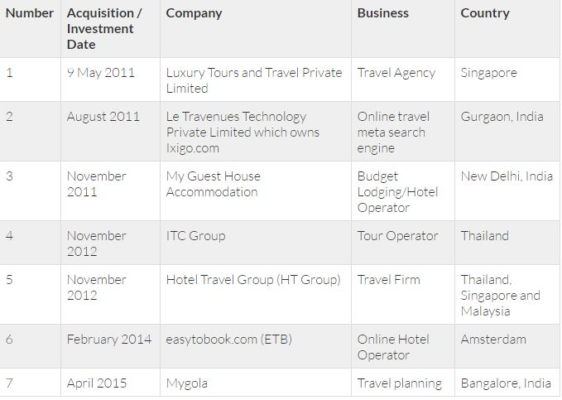

View [Source](http://dsim.in/blog/2015/05/15/case-study-how-makemytrip-became-leader-in-online-travel-agency/): <http://dsim.in/blog/2015/05/15/case-study-how-makemytrip-became-leader-in-online-travel-agency/> (compiled on 11.04.2017)

**Travel & Business Awards**

* Best Travel Innovator – Travel Distribution World Asia Awards 2012
* Best Domestic Tour Operator – Times Travel Honours 2011
* Best Online Travel Service Firm - Times Travel Honours 2011
* Great Places To Work – 2009
* Best Travel Website – CNBC Awaaz – 2008-09
* Among 100 IT Innovators – NASSCOM – 2007
* Asia's Hottest Technology Startup – Red Herring – 2006

**Airline Awards**

* Singapore Airlines : Top agents award (2010-2011)
* Malaysia airlines : Top agent award (2010)
* Cathay Pacific : Outstanding performance in (2009)
* British Airways – Outstanding Revenue Contribution – 2007-08
* Indian Airlines – Achieving Highest Domestic Passenger Sales – 2006-07
* Air India – Outstanding Contribution to Passenger Sales – 2005-06
* Jet Airways – Award of Excellence – 2005-06

**Industry and Competitive Scenario**

Online travel companies like MakeMyTrip, which took over the market share from industry legends like Thomas Cook two years back, have now new competitors; not one or two but around 80 of them. As per an Economic Times report, around 80 start-ups have emerged as strong contenders in the travel industry, with each of them focusing primarily on travel packages and experiential travel to woo customers.

* **Consolidation amongst players**

Major companies are acquiring smaller companies to expand their services. MakeMyTrip acquired Ticketvala, MyGola and RedBus & YourBus were purchased by GoIbibo, Travelocity acquired Travelguru and Yatra acquired Ticket services International.

* **Focus on Hotels and Tours**

For the industry leader Make My Trip, while gross bookings for Air-travel and tours grew by 45%1 each (2008-10), net revenue grew by 49% and 84%, respectively

* **Merging Online and Offline**

Yatra has started 50 lounges across India while Make my trip has an agent network across 450+ cities Yatra has also partnered with Reliance World (120 centres across India) where customers can book tickets and hotels

* **Creating Online Ecosystem**

MakeMyTrip has created online communities of tourists through offisialatyachaar.com and oktatabyebye.com while Cleartrip has associated with Tripadvisor.com

* **Global Expansion of players**

OTAs are expanding globally in countries with high NRI population. MakeMyTrip started trading on Nasdaq to raise money for global operations

* **Strategic Partnership**

Tripoto is amongst one of the big players, which is exploring new spheres with best of technology, consolidation, and strategic partnerships. The company raised an undisclosed sum in March 2015 in a second round of funding led by IDG Ventures, has stitched partnerships both with room-sharing start-up . Airbnb as well as online travel booking company Expedia, are working on similar tie ups. [View Source](http://us.makemytrip.com/various/awards_recognition.html)

**Competitors and Challenges Ahead:**

The Company competes with cleartrip.com, travelocity.co.in, expedia.com, yatra.com, booking.com, goibibo.com, agoda.com, Cox & Kings, Kuoni India, Ezeegol, Thomas Cook and trivago.

* Intense competition from Cleartrip and yatra.com.
* Government’s Digital India initiative is helping a great number of people get online. MakeMyTrip needs to attract these new users.
* As the government is improving its Online Railway ticketing system experience MakeMyTrip needs to use the right tactics before its existing internet users get swayed away.
* IRCTC is adding more services to its offerings. MakeMyTrip needs to counter these and attract more audience.

After a great acquisition spree, MakeMyTrip needs to utilize the Companies it brought under its umbrella to their full potential

Sources and References:

[Wikipedia](https://en.wikipedia.org/wiki/MakeMyTrip#Products_and_services): <https://en.wikipedia.org/wiki/MakeMyTrip#Products_and_services>,

[MakeMyTrip](https://www.makemytrip.com/about-us/company_profile.php): https://www.makemytrip.com/about-us/company_profile.php